### **Lab 04 Memory Management & Stack Observation**

Screenshot 1:

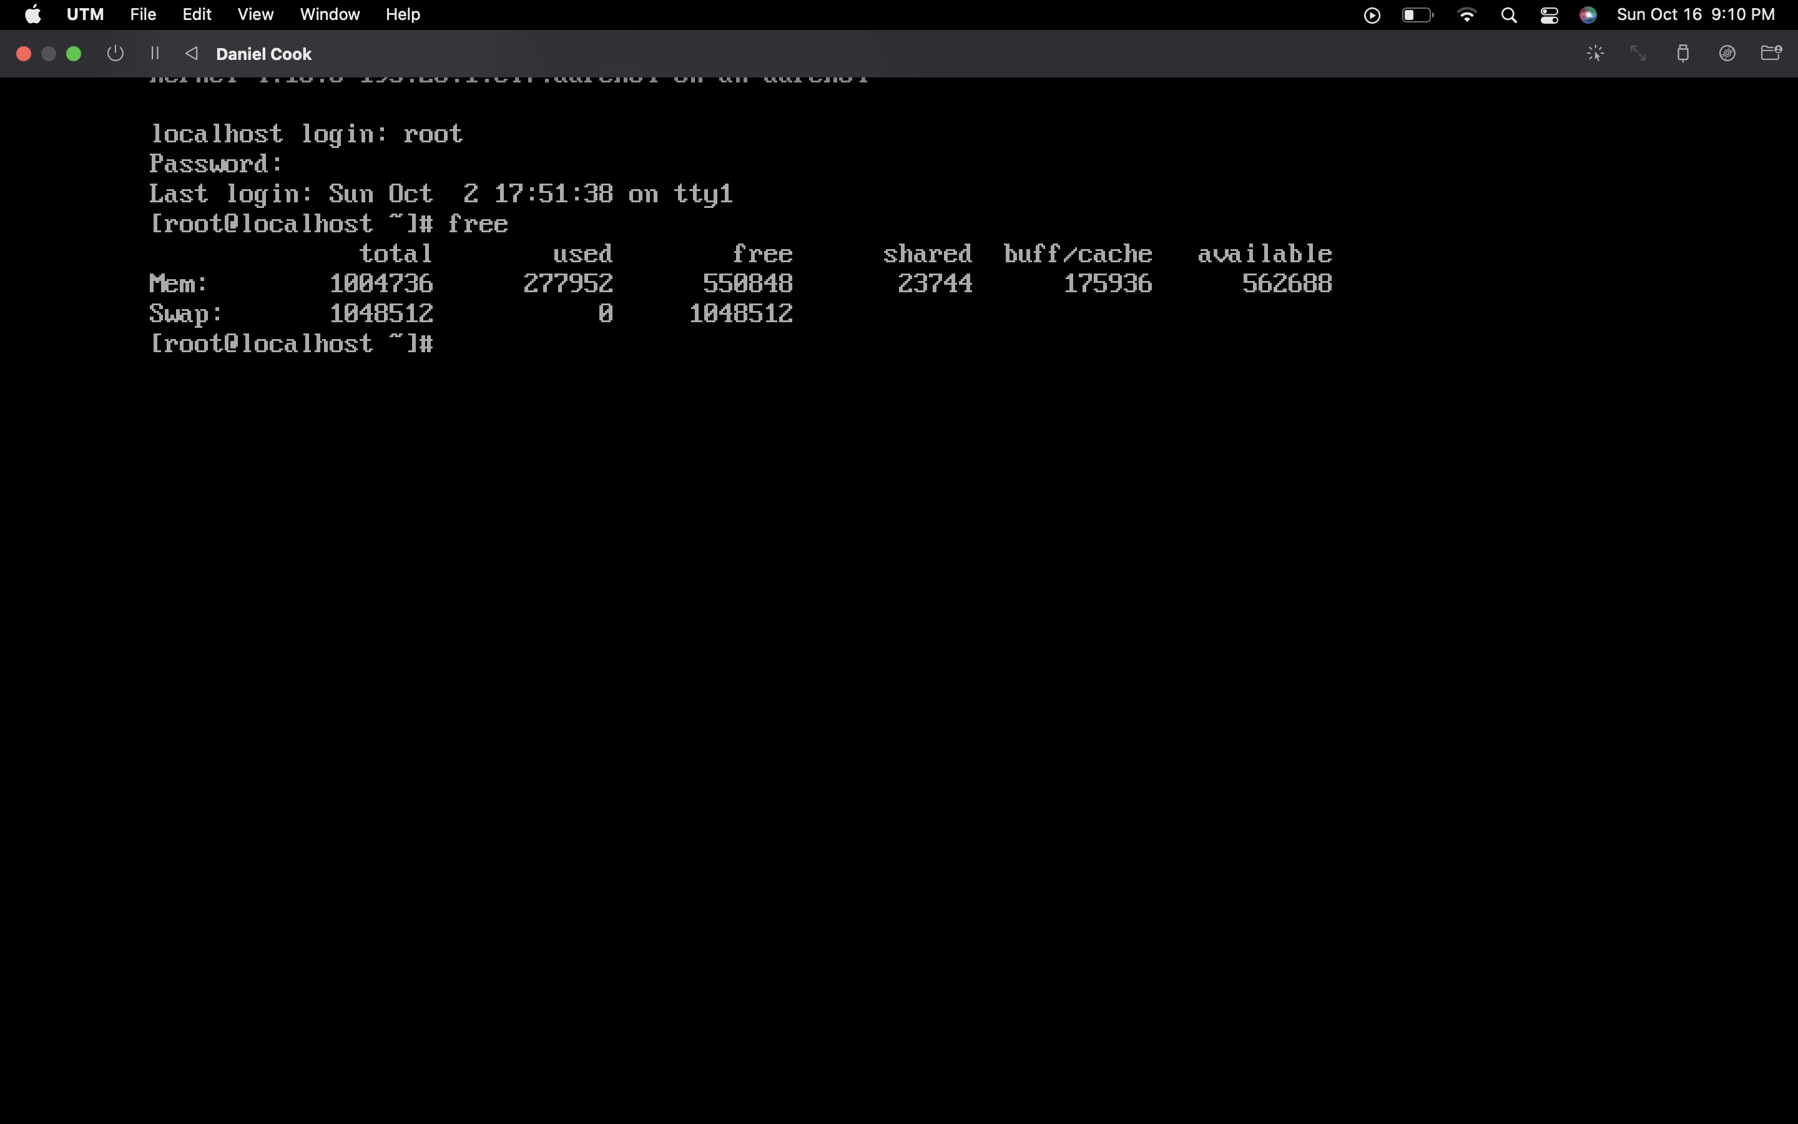

Screenshot 2:

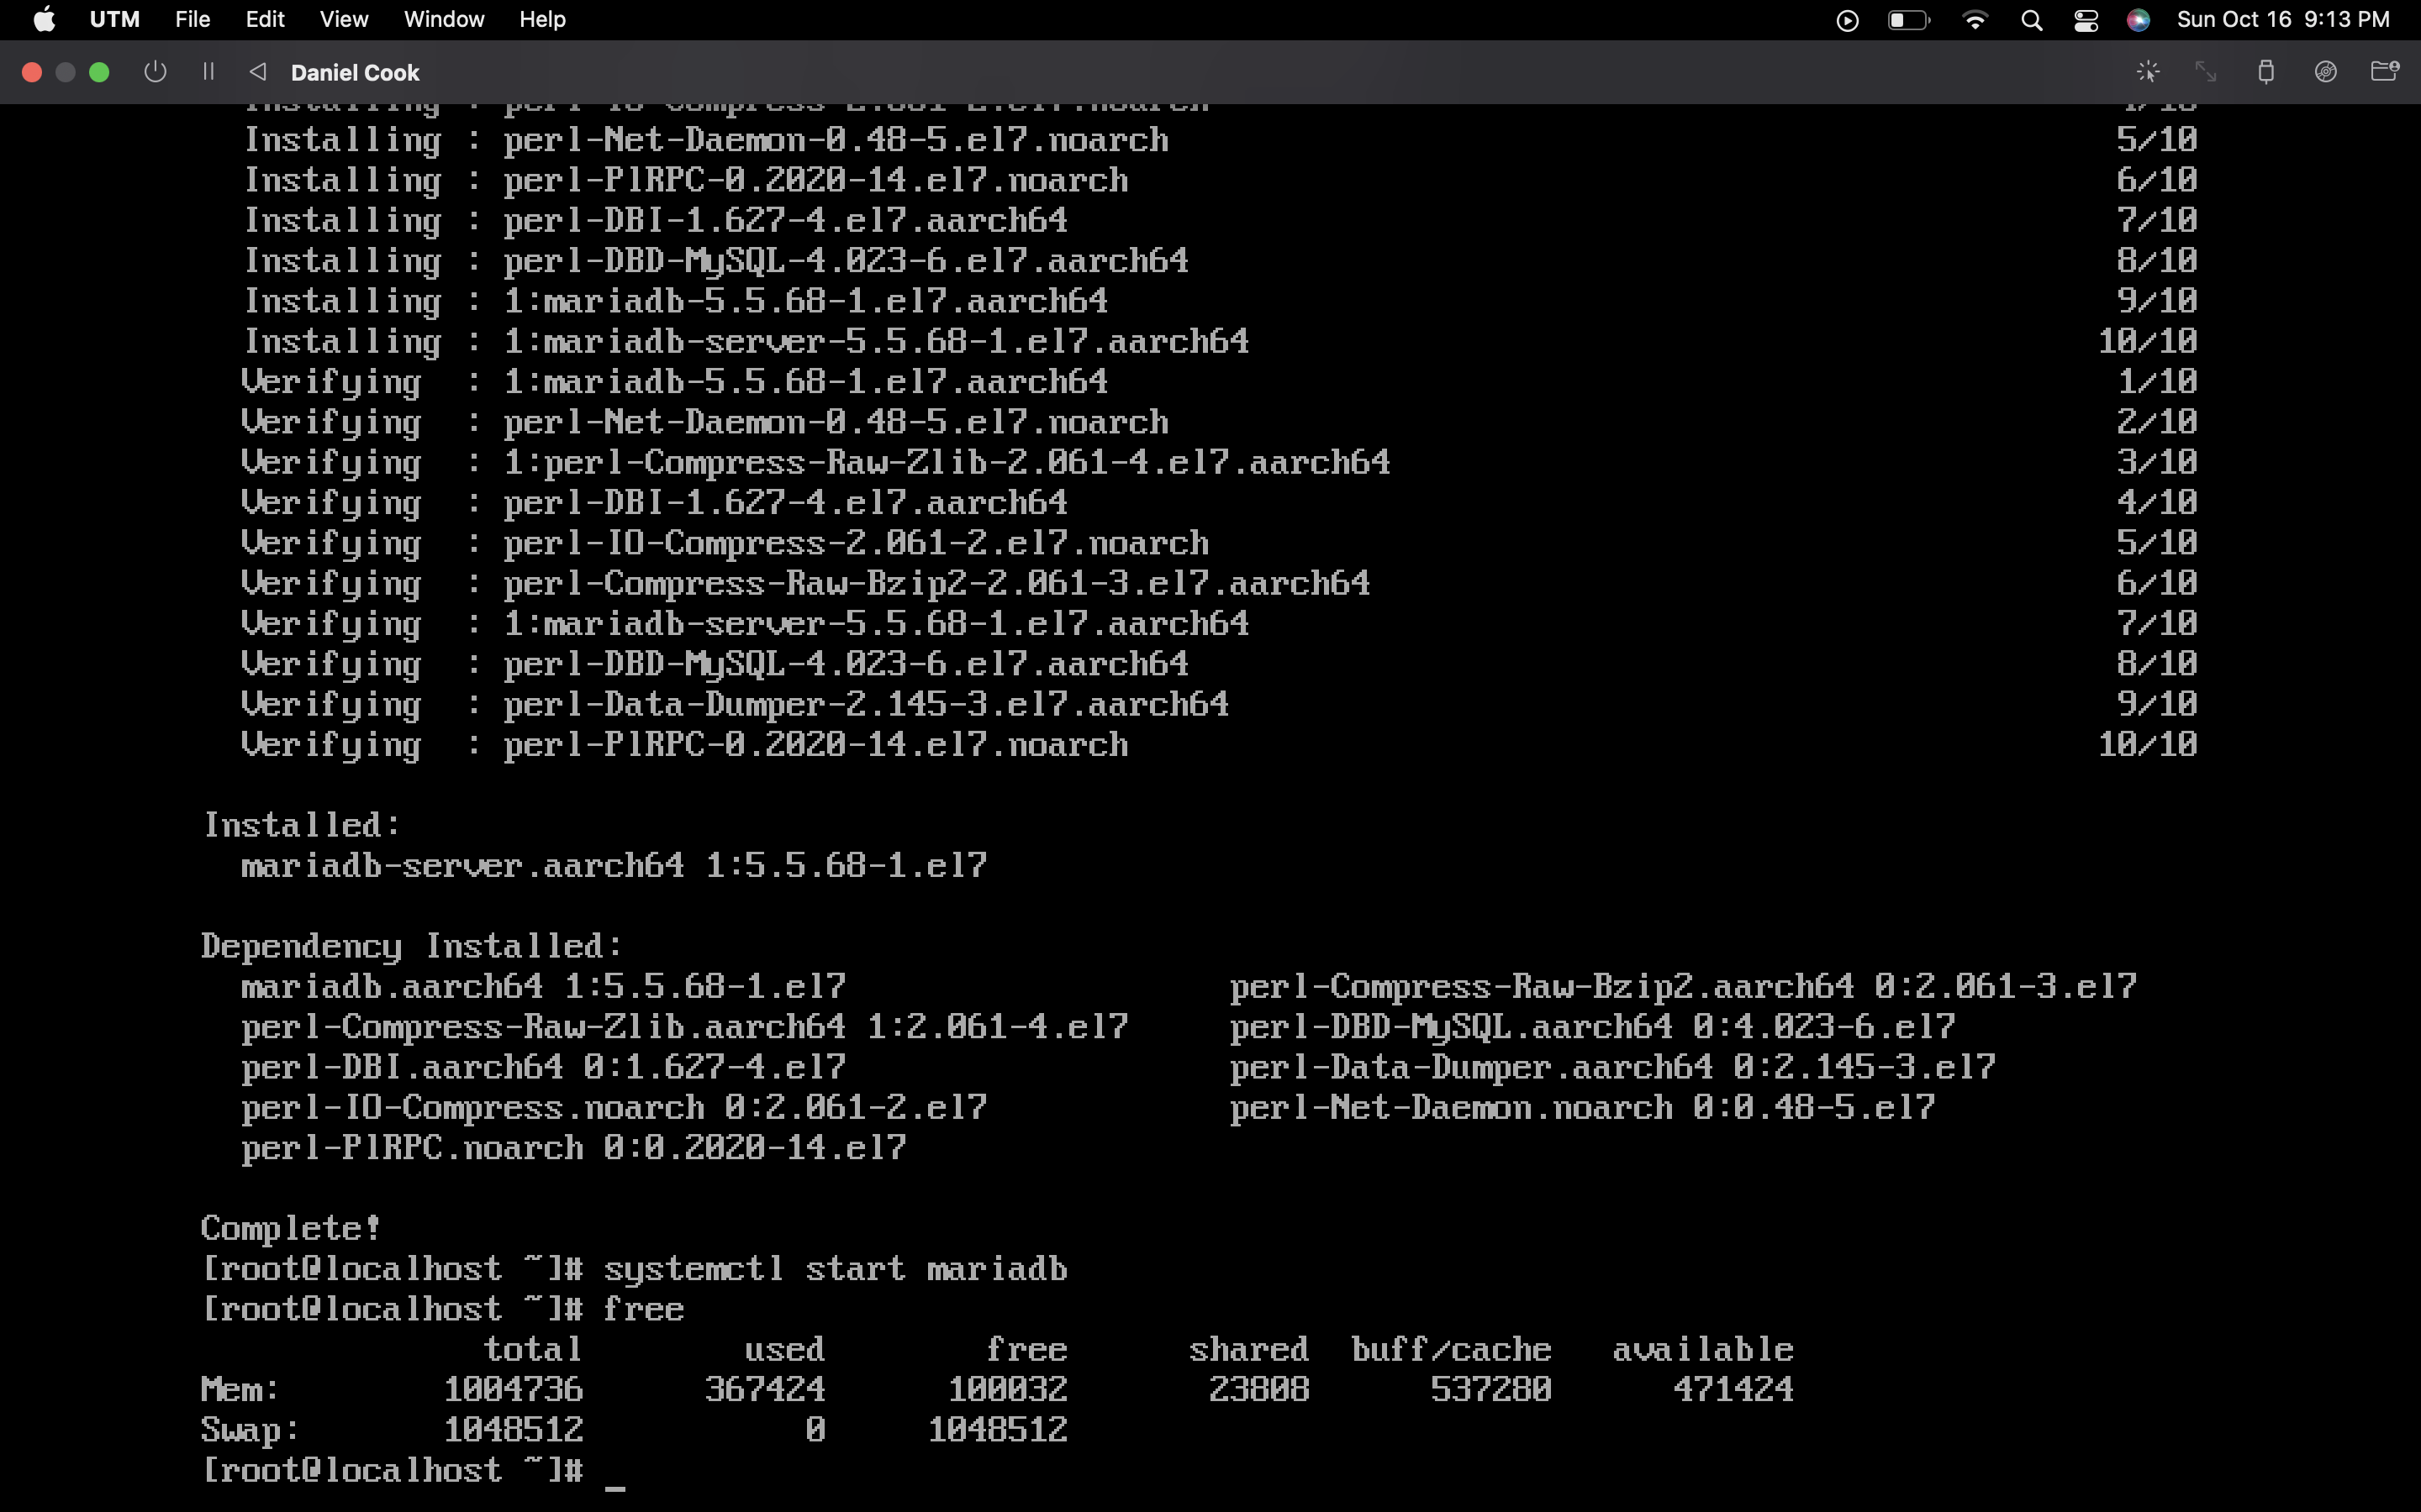

Screenshot 3:

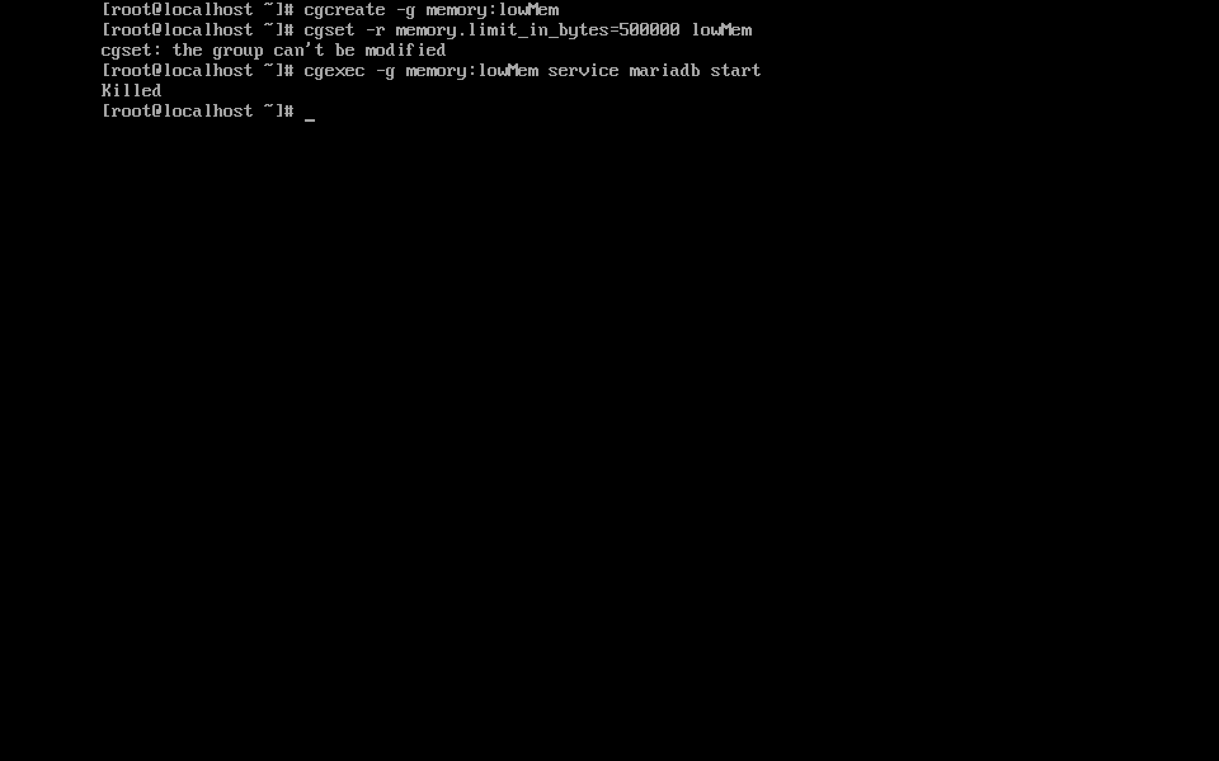

Question: how much memory is approximately needed for launching mariadb (the screenshot should be taken when you find?

All services are running in 50000. You will need at least 4GB to run Mariadb.

Screenshot 4:

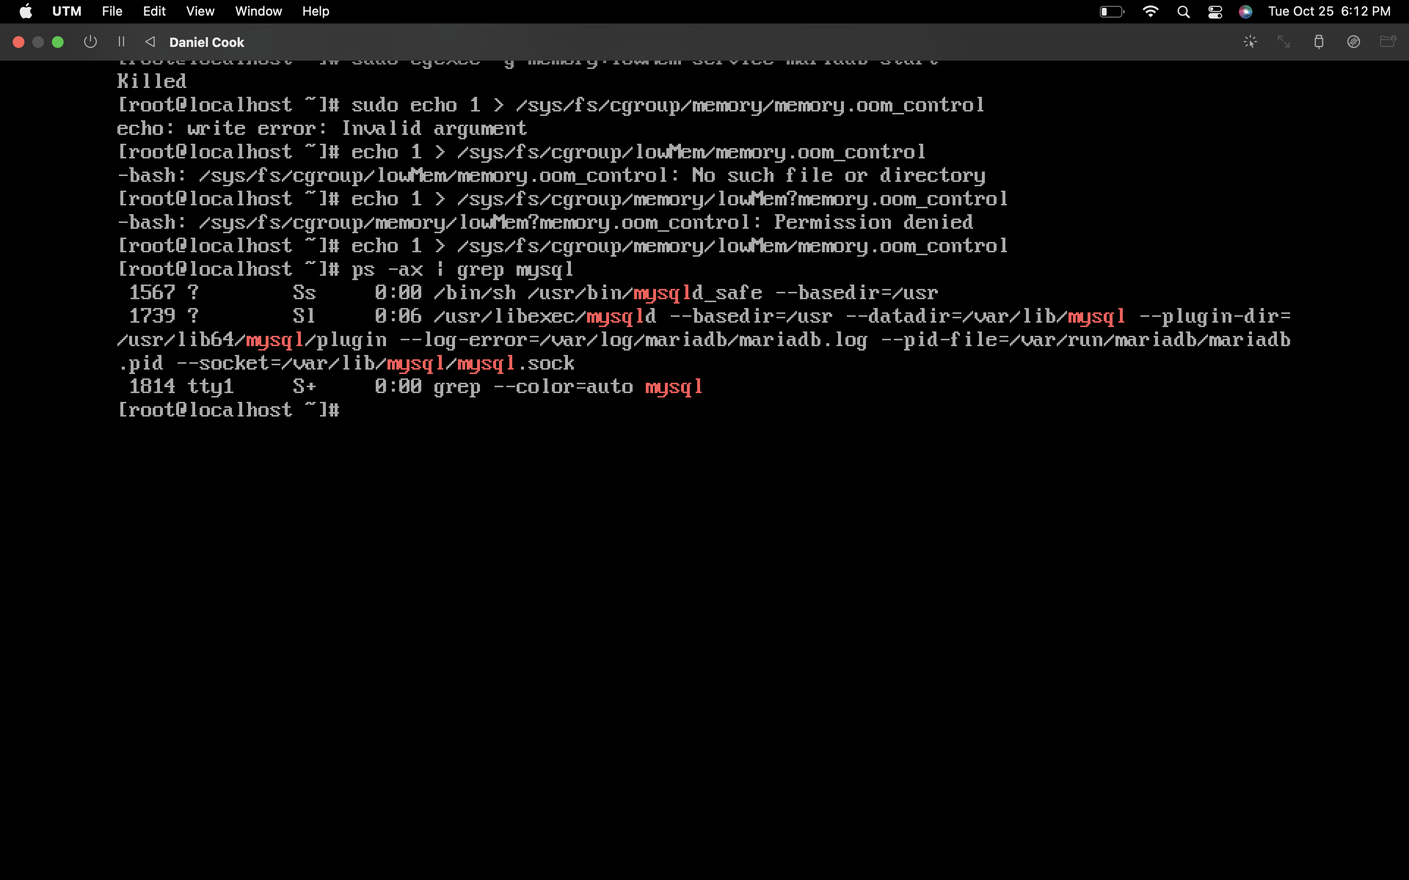

Screenshot 5:

